
REPUBLIC OF KIRIBATI

INVITATION TO QUOTE
WORKS

Date: 15 October 2026

Project Title: Accelerating Trade Facilitation in the Pacific Project (ATFP)
Source of Funding (credit no.): P508537
Contract Name: PMU Office Renovation
Contract Ref: KI-MFED-540858-CW-RFQ

1. This project is financed by the World Bank through the above financing. The ATFP Project under the Ministry of Finance and Economic Development (MFED) invites sealed quotations from eligible bidders for a design-and-build for PMU Office Renovation within the Customs Office in Betio, on a design and build basis as further described in the attached Request for Quotation and scope of works.
2. Eligible bidders should have experience in the construction of at least one contract of a nature and complexity equivalent to the Works described in this Invitation, during the last three years and should provide evidence of financial resources to successfully complete the Works.
3. A complete set of Request for Quotation (RFQ) documents in English will be provided to interested eligible bidders upon the submission of a written application to the address below.
4. This is an open national procurement. In addition to this public advertisement, direct notification of this Invitation will also be provided to a number of known local contractors.
5. Quotations must be submitted to the address below on or before 29th October 2026. Late quotations will be rejected.
6. The address referred to above is:
Attn:
Elizabeth Copeland, Procurement Officer, Accelerating Trade Facilitation in the Pacific Project,
Kiribati Customs Administration and Enforcement Office (KCAE)
Ministry of Finance and Economic Development, Bairiki.
Tel: 75126531/75126532
E-mail: ecopeland@mfep.gov.ki with copy atfpm@mfed.gov.ki and comptroller@customskiribati.gov.ki


REPUBLIC OF KIRIBATI

REQUEST FOR QUOTATION (RFQ-WORKS)

15 October 2026

Project Title: Accelerating Trade Facilitation in the Pacific Project
Source of Funding (loan/credit/grant no.): P508537
Contract Name: PMU Office Renovation
Contract Ref: KI-MFED-540858-CW-RFQ

Dear Bidder,

1. The Ministry of Finance and Economic Development (Employer) under ATFP Project hereby invites you to submit a quotation for the following works: Design and build for PMU Office Renovation

2. To assist you in the preparation of your price quotation we enclose the necessary Specifications, Bill of Quantity (BOQ), Drawings, and Form of Contract.

Please note that the pre-quotation meeting shall take place
at the following address, date and time:
Venue: Kiribati Customs Administrative and Enforcement Boardroom, Betio
Date: 22nd October 2026
Time: 2:00 PM local time

All bidders are requested to arrive with their questions that need further clarification for the mentioned tender.

3. You may submit the signed Form of Quotation including the priced BOQ by hand delivery or electronically at the following address:

Attn: Elizabeth Copeland, Procurement Officer
Address: KCAE, Ministry of Finance and Economic Development, Bairiki
Email address: ecopeland@mfed.gov.ki with copy atfpm@mfed.gov.ki and comptroller@kiribaticustoms.gov.ki

4. You must have experience as a contractor in the construction of at least one contract of the nature and complexity equivalent to the works included in this RFQ over the last three years and provide evidence of financial resources to successfully complete the works of this contract.

5. Each bidder shall submit only one quotation. All quotations submitted in violation of this rule shall be rejected.

6. In evaluating the quotations, the Employer will determine for each quotation the evaluated price by adjusting the price quotation by making any correction for any arithmetical errors as follows:
(a) where there is a discrepancy between amounts in figures and in words, the amount in words will govern;
(b) where there is a discrepancy between the unit rate and the line item total resulting from multiplying the unit rate by the quantity, the unit rate as quoted will govern;
(c) if a Bidder refuses to accept the correction, his quotation will be rejected.

7. Your quotation shall be valid for a period of sixty (60) calendar days from 29th October, 2026
(deadline for submission of the quotation).

8. Your quotation in English language shall be for the whole works and based on the unit rates specified in the Bill of Quantities for a fixed unit rate contract. Currency of quoted prices and payment shall be in Australian Dollars (AUD). The quotation shall include all duties, local taxes and other levies payable by the contractor in accordance with the local laws.

9. The Employer will award the contract to the Bidder whose quotation has been determined to be substantially responsive to this RFQ, has offered the lowest evaluated price quotation and is qualified to do the Works.

10. The terms and conditions of contract are attached to this RFQ.

11. Your quotation should be submitted by 29th October, 2026, 10:00pm (Tarawa Time)

12. Further information for the RFQ can be obtained from:
ATFP Project, KCAE Office (Betio)
Ministry of Finance and Economic Development,
Name of contact person: Elizabeth Copeland, Procurement Officer, ATFP
Telephone: 75126531/75126532

E-mail: ecopeland@mfed.gov.ki with copy atfpm@mfed.gov.ki and comptroller@kiribaticustoms.gov.ki

13. Please confirm by fax/e-mail to the contact provided in paragraph 12 above, the receipt of this RFQ and whether or not you will submit the price quotation(s).

Sincerely,

Ereta Turaki,
Project Manager,
KCAE, Ministry of Finance and Economic Development.
REPUBLIC OF KIRIBATI
NOTIFICATION OF AWARD

[date]
To: [name and address of the Winning Bidder]

Project Title: Accelerating Trade Facilitation in the Pacific Project
Source of Funding (loan/credit/grant no.): P508537
Contract Name: PMU Office Renovation
Contract Ref: KI-MFED-540858-CW-RFQ

Notification of Award

This is to notify you that your Quotation dated ……. [insert date] ……. for execution of the PMU Office Renovation is hereby accepted for the Contract Amount of . . . . . . [insert amount in numbers and words and name of currency], as corrected and modified in accordance with the Request for Quotation (RFQ).
You are requested to countersign the attached Contract Agreement, and return it to the Employer at the following address within 2 days:
ATFP Project, KCAE(Betio)
Ministry of Finance and Economic Development.

Authorized Signature:
Name and Title of Signatory:
Name of Employer:

Attachment: Contract Agreement signed by the Employer, with accepted priced BOQ, Specifications and Drawings

FORM OF CONTRACT: RFQ FOR WORKS

Name of Country: Kiribati
Project Title: Accelerating Trade Facilitation in the Pacific Project
Source of Funding (credit no.): P508537
Contract Name: PMU Office Renovation
Contract Reference number : KI-MFED-540858-CW-RFQ

This Contract is made this _______________ day of (insert month in words) 2024 between (insert the legal name of the Employer)_______________________________________on the one part (hereinafter called “the Employer”) and _( insert the legal name of the bidder)__________ (hereinafter called “the Contractor”) on the other part.

Whereas the Employer has called for quotations for (name and identification number of the contract) (“the Works”) and the Contractor has submitted a quotation for the Works and the Employer has accepted the Contractor’s Quotation dated (Day/Month/ Year _____) for the execution and completion of the Works and the remedying of any defects therein.

Now this Contract witnesses as follows:

- The Contractor hereby covenants to execute the Works fully detailed in the drawings, technical specifications and Bill of Quantities (BOQ) included in the Contractor’s Quotation (Annex 1) which constitute an integral part of this Contract in a professional and workmanship like manner in accordance with the following Conditions of Contract, The site specific ESCOP, including its Worker; Code of Conduct and grievance arrangements, forms an integral part of this Contract. The Contractor shall implement these requirements and include all associated implementation costs in the Contract Price:

    - Remedy all defects within 7 working days of notification by the Engineer in charge ________ (name), during the period of execution of the contract and thereafter for defects notified within the defect liability period.
    - The Employer reserves the right to terminate the contract due to unsatisfactory performance 10 days after giving a written notice.
    - All material and construction equipment on site, temporary works, and the Works shall be deemed to be the property of the Employer if the contract is terminated due to default by the Contractor.
    - The Contractor will in all cases abide by the directions of the Engineer in charge.
    - The Contractor shall submit to the Engineer in charge, a program within 7 days after signing the contract describing general methods and schedule to complete the Works.
    - The Contract completion period shall be [ninety (90)] (calendar days) after signing of the Contract.
    - In case of changes to the quantities in BOQ, the unit rates under the contract will be used to calculate the payment. For variations, the unit rates in the BOQ shall be used for similar items under variation. New items of work performed, under variation as ordered by the Engineer in charge, will be paid at mutually agreed rate/s and, in case of any disagreement between the Contractor and the Engineer in charge, the latter will fix the unit rates that will be binding on the Contractor.
    - The Law governing the contract shall be the applicable laws of Kiribati.
    - The Contractor shall be responsible for the safety of all the activities on the Site.
    - During execution of the Works the Engineer in charge will carry out inspection of the Works at site to verify that the Works are executed by the Contractor in accordance with the specifications and required quality as per specifications. The Engineer in charge will reject works not performed to the required specifications and the Contractor shall take immediate actions to rectify all defects in accordance with subparagraph (a) above.
    - Either party may terminate the Contract by giving a 14 days’ notice to the other for unforeseen events such as wars and acts of God such as earthquake, floods, fires etc. In such case the payments will be made for the completed works to the date of termination of contract.
    - The Contractor is responsible for all taxes, duties, levies, customs duties, etc. in accordance with the laws of Kiribati which are already included in the unit rates or prices in the BOQ or AS, except VAT.
    - Any disputes between the Employer and the Contractor arising under or in connection with the Contract shall be resolved amicably. In the event the dispute remains unresolved, either party may refer the dispute to arbitration in accordance with Kiribati Law.

- In consideration thereof the Employer covenants to pay the Contractor the Contract Price of [to be inserted upon award] (in words and figures) in the following manner and instalments, based on the physical milestones set out below:

Payment Milestones:
Claim | Milestone Condition | Target | Share | Retention | Minimum certification evidence
1 | Measured survey, coordinated detailed design, programme and schedules approved; written design hold point achieved; mobilisation complete; approved major materials evidenced or delivered; and demolition complete. | End Wk 3 | 15% | 5% of claim | Approved drawings and programme written approval to proceed, site inspection, procurement or delivery evidence, photographs and measured demolition.
2 | Timber partitions and feature-wall framing complete; concealed framing and electrical first fix inspected before closure. | End Wk 5 | 25% | 5% of claim | Joint measurements, photographs and signed concealed-work inspection
3 | Louvres, sliding window, entrance door, internal doors, linings, electrical second fix and principal finishes substantially installed and accepted. | End Wk 7 | 25% | 5% of claim | Installation inspection, product records, test records and recorded defects or outstanding work.
4 | Practical Completion achieved; all remaining works and defects completed; testing, electrical certification, cleaning, as-built information, warranties and handover accepted | End Wk 8 | 35% | 5% of claim | Practical Completion certificate, closed pre-completion defect list and complete accepted handover package.

(A) Each payment shall be made following certification by the Engineer in Charge that the relevant milestone has been achieved. Each payment will be due within (number of days) days of submission of invoice and supporting documents for the certified milestone.

(B) The defects liability period will be 12 months after taking over of completed works by the Employer.

(C) Final payment shall not due until the handover documentation required under this Contract has been submitted and accepted by the Employer.

3. Inspections and Audits
3.1 The Contractor shall carry out all instructions of the Engineer in charge which comply with the applicable laws where the Site is located.
3.2 The Contractor shall permit, and shall cause its Sub-Contractors to permit, the World Bank (“the Bank”) and/or persons or auditors appointed by the Bank to inspect and/or audit its accounts and records and other documents relating to the submission of the Quotation to carry out the Works and performance of the Contract. Any failure to comply with this obligation may constitute a prohibited practice subject to contract termination and/or the imposition of sanctions by the Bank (including without limitations determination of ineligibility) in accordance with prevailing Bank’s sanctions procedures.

- Termination.
The Employer may terminate this Contract with at least ten (10) working days prior written notice to the Contractor after the occurrence of any of the events specified in paragraphs (a) through (d) of this Clause:

(a) If the Contractor does not remedy a failure in the performance of its obligations under the Contract within seven (7) working days after being notified, or within any further period as the Engineer in charge may have subsequently approved in writing;
(b) If the Contractor becomes insolvent or bankrupt;
(c) If the Contractor, in the judgment of the Employer or the Bank, has engaged in corrupt, fraudulent, collusive, coercive, or obstructive practices (as defined in the prevailing Bank’s sanctions procedures) in competing for or in performing the Contract.
(d) If the Employer, in its sole discretion and for any reason whatsoever, decides to terminate this Contract.
- Fraud and Corruption
If the Employer determines that the Contractor and/or any of its personnel, or its agents, or its Subcontractors, consultants, service providers, suppliers and/or their employees has engaged in corrupt, fraudulent, collusive, coercive or obstructive practices (as defined in the prevailing Bank’s sanctions procedures), in competing for or in executing the Contract, then the Employer may, after giving 14 days’ notice to the Contractor, terminate the Contractor's employment under the Contract and cancel the contract, and the provisions of Clause 4 shall apply as if such expulsion had been made under Sub-Clause 4(a).
In witness whereof the parties thereto have caused this Contract to be executed the day and year first before written.

________________________  Signature (on behalf of the Employer)  In the presence of:  _______________________  (Signature of Witness)  Name and designation of Witness: | Name of the Contractor:  ___________________________  Signature on behalf of Contractor  In the presence of:  _____________________  (Signature of Witness)  Name and Address of Witness:

ANNEX 1: SPECIFICATIONS

Project Title: Accelerating Trade Facilitation in the Pacific Project
Source of Funding (loan/credit/grant no.): P508537
Contract Name: PMU Office Renovation
Contract Ref: KI-MFED-540858-CW-RFQ

- Brief Background

- The Accelerating Trade Facilitation in the Pacific Project is a World Bank funded programme implemented by the Kiribati Customs and Administration Enforcement (KCAE) Office under the Ministry of Finance and Economic Development (MFED), Government of Kiribati.
- The PMU office renovation - including the Customs Office Betio works covered in the RFQ - supports this project by providing the PMU and KCAE-related customs functions with a fit-for-purpose working environment (offices, boardroom, and support facilities) needed to deliver the project's customs and trade facilitation activities.
- This is the Employer’s Design Brief and technical pricing basis for the design and construction of the proposed Customs Office renovation. It defines the required performance, indicative geometry and minimum standards, but is not a complete construction design. Tenderers shall verify the site, develop a preliminary design with their quotation, complete the coordinated detailed design after award, construct the approved works and identify all departures, assumptions and exclusions.
- Design-and-Build Contract Requirements
- The Contractor shall undertake a measured site survey and is responsible for the adequacy, completeness, coordination, compliance and constructability of its design and the completed works.
- The quotation shall include a preliminary design proposal demonstrating the proposed layout, appearance, construction method, materials, services coordination and compliance with this Employer’s Design Brief and Specification.
- Following award, the Contractor shall prepare coordinated detailed design documents, including dimensioned plans, demolition and proposed-work plans, elevations, sections, feature-wall and framing details, reflected ceiling/electrical layouts, door and window schedules, finishes, product information and applicable calculations or supplier certification.
- The detailed design shall address life and fire safety for the renovated areas and adjoining occupied offices, including safe escape routes, unobstructed exits, appropriate door arrangements and fire detection, alarm and firefighting provisions specified by the Employer. The contractor shall incorporate these requirements into the coordinated design and include their costs in the quotation.
- Tendered prices shall include all surveys, professional design input, drafting, coordination, review revisions, shop drawings, samples, construction information and as-built documentation required for the design-and-build obligation.
- Review, comment or approval by the Client does not relieve the Contractor of design responsibility. No design-dependent fabrication, procurement, demolition or construction shall proceed before written approval of the relevant detailed design submission.
- General Contractor Requirements
- Inspect the site before pricing and verify access, existing dimensions, services, finishes and the condition of items to remain. Failure to inspect the site shall not relieve the Contractor of responsibility for assessing access, dimensions, services, working conditions, waste disposal requirements and ordinary construction risks.
- Provide all labour, supervision, materials, plant, tools, transport, fixings, consumables and incidentals necessary to complete the work.
- Protect occupied areas, furniture, finishes and services that are to remain. Maintain safe access and minimise dust, noise and disruption.. The contractor shall be responsible for any damage caused to existing buildings, furniture, equipment, services or finishes arising from the contractor’s operation and shall reinstate such damage at no additional cost to the Client.
- Coordinate shutdowns, demolition and electrical alterations with the Client before commencing each activity. Normal working hours shall be agreed with the Client prior to commencement of works. Any work outside approved working hours shall require prior approval from the Client
- Remove debris and surplus materials from the site and leave all affected areas clean, safe and ready for occupation.
- Make good all surfaces disturbed by the work, including wall linings, framing, skirtings, cornices, ceilings, floors and paint finishes where applicable.
- Comply with applicable building, electrical, workplace-safety and environmental requirements. Electrical work shall be carried out and tested by appropriately qualified personnel.
the Contractor shall comply with the site-specific Environmental and Social Code of Practice (ESCOP), including its annexes, attached as Annex 6. These requirements apply to the Contractor, subcontractors and all workers. The quotation shall include all associated implementation costs, including the designated Health and Safety Officer, worker induction, personal protective equipment, protective barriers, monitoring and waste management.
- Promptly notify the Client of discrepancies between this scope and actual site conditions before proceeding with affected work. The contractor shall immediately notify the Client of any concealed conditions, hazardous materials, structural defects, termite damage, water damage or other unforeseen site conditions identified during the works. No remedial work associated with such conditions shall proceed without written instruction from the Client.
- Coordinate the design with existing structure, ceilings, floors, services, air-conditioning equipment, fire-safety equipment and the operational needs of occupied office areas.
- Maintain current approved drawings on site and obtain written approval for substitutions and departures before carrying out the affected work.
- Safeguards, Health and Safety and Environmental Requirements.
Requirement | Minimum Requirement/ Clarification
ESCOP compliance | The Contractor and all subcontractors shall comply with the site specific ESCOP attached to this RFQ, including its Workers Code of Conduct and grievance arrangements. The ESCOP shall form part of the Contract. All implementation costs shall be included in the quotation.
ECD inspection before and during demolition | Before opening or removing existing partitions or other suspect building materials, the Contractor shall notify the PMU to arrange the further inspection advised by ECD. Work affecting those materials shall proceed only after documented ECD advice or clearance and written Client authorization.
General Safeguards | The contractor shall perform works in a manner that protects workers, building occupants, visitors, the public and the environment. All applicable workplace health and safety, environmental and waste management requirements shall be complied with.
Health and Safety Plan | The contractor acknowledges that the building is of considerable age and shall exercise appropriate caution during demolition and renovation activities due to the potential presence of asbestos-containing materials and other hazardous building products.
Building Age and Hazardous Materials | The contractor acknowledges that the building is of considerable age and shall exercise appropriate caution during demolition and renovation activities due to the potential presence of asbestos containing materials and other hazardous building products.
Suspected Asbestos Materials | If suspected asbestos containing material is encountered, the Contractor shall immediately cease work in the affected area, isolate the area, restrict access and notify the client. The material shall not be disturbed, removed, cut, drilled, broken or transported by the Contractor.
Asbestos Assessment and Removal | Assessment, management, removal and disposal of confirmed asbestos-containing materials shall be undertaken by the appropriate authority designated by the client, including ECD where applicable. The Contractor shall cooperate fully and shall not recommence work in the affected area until written authorization is provided by the client.
Grievance arrangements | Inform workers of the worker grienvace arrangements and affected people of the existing ATFP project GRM. Cooperate with the PMU in addressing complaints,prohibit retaliation and handle SEA/SH concerns confidentially through the agreed referral process.
Dust, Noise and Air Quality Control | The Contractor shall minimize dust, noise and disruption through appropriate work practices, including dust suppression, segregation of work areas and regular site cleaning.
Protection of Occupied Areas | The contractor shall maintain safe access to occupied office areas, install temporary barriers and warning signs where required, and ensure construction activities do not unduly disrupt Customs operations.
Waste Conduct and Labour protection | All workers shall sign and comply with the attached workers code of conduct and receive induction before starting work. Child Labour, forced labour, harassment , sexual exploitation and abuse, and sexual harassment are prohibited. The Contractor shall verify that all renovation workers are at least 18 years old.
Waste Disposal Fees | The Contractor’s prices shall include all costs associated with the collection, transport and disposal of ordinary construction and demolition waste, including landfill charges. No additional payment shall be made for these items unless approved in writing by the Client
Hazardous Waste | Before disturbing suspect building materials, the Contractor shall comply with the inspection and clearance requirements of the ESCOP. If suspected asbestos or other hazardous material is encountered, immediately stop work in the affected area, isolate it and notify the Client. Do not cut, drill, break, remove or otherwise disturb the material. Work shall resume only following documented advice or clearance from ECD through the Client. Confirmed asbestos shall be managed in accordance with the MELAD-approved ACM management procedure and the approved activity-specific ACM management plan.
Worker Conduct | The contractor shall ensure that all personnel behave professionally, comply with site security requirements and respect the operations of Customs staff and visitors.
Compliance Documentation | Before physical work commences, the Contractor shall submit a site-specific Health and Safety Plan, task risk assessments, safe work procedures, waste management procedures and emergency response arrangements consistent with the ESCOP for the Client’s review and approval. The Contractor shall also provide the appointed Health and Safety Officer’s name, qualifications and contact details, signed Workers’ Codes of Conduct, and details of the confidential worker grievance channel. Physical works shall not commence until the applicable ESCOP pre-start requirements have been met.
Incident reporting and monitoring | Immediately notify the PMU of incidents, near misses and unsafe conditions. Maintain inspection and corrective action records, allow PMU monitoring and comply with

- Employer’s Design Brief and Detailed Scope of Work

The requirements and quantities below are the Employer’s indicative tender-pricing basis. Tenderers shall verify them by site inspection and measured survey. The successful Contractor remains responsible for the final measured design and complete installation.

4.1 Ground Floor - Principal Customs Officer Office
Ref. | Required Work | Pricing Basis | Minimum Requirement / Clarification
1.1 | Demolish the existing partition between two rooms in the Principal Customs Officer office area. | 6.307 m² | Measured from 2.38 m x 2.65 m. Carefully disconnect affected finishes and services; dispose of debris; make good adjoining surfaces. Demo to be confirmed with Client once contract is awarded.
1.2 | Remove one existing single door and reframe the opening in timber. | 1 item | Include framing, wall closure or lining as required, skirting, preparation and matching paint finish.
1.3 | Carry out minor electrical alterations within the room. | 1 room / provisional allowance | Allow for relocation or refixing of lights, switches, GPOs and related wiring made necessary by the approved arrangement. Confirm exact requirements on site.

4.2 Kitchen

Ref. | Required Work | Pricing Basis | Minimum Requirement / Clarification
2.1 | Remove the roller door at the kitchen bar opening. | 1 item | Include safe removal, disposal and making good of the surrounding opening and finishes.
2.2 | Supply and install one single door. | 1 item | Include door leaf, frame, architraves, ironmongery, stops, fixing, adjustment and complete paint or specified finish.
2.3 | Supply and install one aluminum sliding glass window. (See sample at the appendix D) | 1.80 m² | Current basis is 1.20 m x 1.50 m. Include frame, glazing, tracks, hardware, perimeter sealing, flashings/making good and installation. State proposed product and lead time if it is to be imported.
2.4 | Carry out minor electrical alterations in the kitchen. | 1 provisional sum | Include refixing of GPOs, light fittings and switches. Current take-off identifies three GPOs; and one ceiling light.
Bidder pricing note: Sliding window products may require importation. The bidder shall identify and separately include all applicable freight, duties, handling and delivery costs, rather than assuming these are excluded.

4.3 Second Floor

Ref. | Required Work | Pricing Basis | Minimum Requirement / Clarification
3.1 | Demolish the timber-framed partition between the existing Principal Customs Officer office and boardroom. | 11.313 m² | Measured from 4.19 m x 2.70 m. Include disconnection of affected fittings, debris removal and complete making good. Confirm with client upon contract award.
3.2 | Remove the main curtain entrance door. | 1 item | Include removal of associated frame, tracks or fittings where applicable and making good.
3.3 | Remove the curtain door/wall at the existing boardroom entrance. | 1 item | Include all associated demolition, disposal and making good.
3.4 | Construct the full-height boardroom/corridor timber-framed partition. | 13.989 m² | Measured from 5.181 m x 2.70 m. Use treated nominal 2x4 (90 x 45 mm) timber framing, studs at maximum 600 mm centres, double top plate, single bottom plate and noggings. Include linings both sides, insulation if specified, fixings, skirtings, cornices, joint treatment and complete paint finish.
3.5 | Construct the full-height timber partition for the ATFP office. | 29.700 m² | Gross measurement: 6.80 m x 2.70 m + 3.20 m x 2.70 m + 1.00 m x 2.70 m. Use the same treated 90 x 45 mm framing system as item 3.4. No deductions were made in the source take-off; verify openings and net quantities before pricing.
3.6 | Design and construct the full-height timber-framed feature wall incorporating an end-to-end horizontal bank of aluminium-framed operable glass louvre windows. (see sample in annex D) | Indicative: 8.80 m wall length x 2.70 m high; 9.680 m² louvre opening | Use treated nominal 2x4 (90 x 45 mm) timber framing with lined and painted solid wall approximately 1.00 m below the louvres and 0.60 m above. Louvre band is approximately 8.80 m x 1.10 m. Include timber trimming, sill, header and jambs; aluminium modules/mullions; operable glass blades and handles; closures, seals and trims. General appearance shall be similar to Appendix E. Contractor to survey, design, detail and obtain approval before fabrication.
3.7 | Supply and install one commercial-grade aluminium-framed glazed double entrance door set. (See sample in annex D | 1 item | Include door leaves, frame, safety glazing, heavy-duty hinges, handles, locks, stops, closers where required, corrosion-resistant fixings, perimeter sealing, adjustment and finish. Submit product data before ordering.
3.8 | Supply and install single internal doors. | 4 items | Current basis: two ATFP office doors and two boardroom entrance doors. Include complete frames, architraves, ironmongery, locks/latches, stops and finishes.
3.9.1 | Minor electrical alterations - ATFP office. | 1 room / provisional allowance | Include required relocation/refixing of GPOs, lights and switches, associated wiring, testing and making good.
3.9.2 | Minor electrical alterations - boardroom. | 1 room / provisional allowance | Include required relocation/refixing of GPOs, lights and switches, associated wiring, testing and making good.
3.9.3 | Minor electrical alterations - reception. | 1 room / provisional allowance | Include required relocation/refixing of GPOs, lights and switches, associated wiring, testing and making good.

- Technical and Workmanship Requirements

Work Category | Minimum Specification
Demolition | Confirm services before cutting or removal. Undertake demolition carefully so that retained work is not damaged. Remove all demolition and construction waste from the premises and dispose of it lawfully at an approved waste facility. The contractor’s rates shall include all transport. handling, landfill, tipping and disposal charges associated with ordinary construction waste. .
Timber partitions | Use treated, seasoned and straight nominal 2x4 timber (approximately 90 x 45 mm). Unless approved otherwise, studs shall be at maximum 600 mm centres with double top plate, single bottom plate, at least one continuous row of noggings, and additional studs, headers and blocking at doors, louvres, corners and junctions. Isolate bottom plates from concrete/masonry and treat cut ends.
Wall linings and finishing | Line both faces with 10-13 mm plasterboard unless noted otherwise. Use full-height sheets where practicable, compatible screws, tape, compound and corner beads. Finished surfaces shall be straight, even and ready for decoration. Provide skirtings and cornices to match adjacent work.
Doors and hardware | Confirm opening sizes and handing before manufacture or procurement. Install complete, aligned and freely operating doors, frames, locks/latches, handles, hinges, stops and associated trim.
Windows and louvres | Confirm dimensions by measured survey. The feature wall shall be a full-height treated timber-framed, plasterboard-lined and painted partition containing an inset continuous horizontal bank of aluminium-framed operable glass louvre windows, generally similar to Appendix E. Provide glass blades, aluminium subframes, operating handles, module mullions, timber trimmers, sill and header, corrosion-resistant fasteners, closures, trims and compatible sealant. Submit elevation, sections, module sizes, blade type/thickness, framing/fixing details, finish samples and product data. The complete assembly shall be straight, stable, safe, durable and freely operating.
Painting | Prepare surfaces, spot-prime exposed or repaired materials, and apply a compatible complete paint system. Colour and sheen are subject to Client approval.
Electrical work | Coordinate final outlet and light positions with the Client. Reuse existing equipment only where serviceable. Complete all wiring, connections, testing, labelling and certification required by applicable rules.

- Exclusions and Items Requiring Confirmation
- Furniture is excluded from the work unless added by formal clarification or addendum.
- Supply of new air-conditioning units is excluded. Existing units are to remain unless the Client issues a specific instruction. The existing inventory records one broken unit in the ATFP area.
- Final door, window, operable glass louvre and hardware types, materials, colours and finishes shall be developed by the Design-and-Build Contractor and approved before procurement.
- Kitchen light-fitting quantities and detailed electrical relocation requirements remain to be confirmed following site inspection.
- The exact site/location, access restrictions, permitted working hours, tax treatment and quotation currency are to be stated in the RFQ cover letter or clarified before award.
- The tentative material schedule is a budgeting and tender-checking aid only. Bidders remain responsible for their own take-off, waste factors, final quantities and complete installation.
- The estimate carries five single internal door sets in total, while the original TOR referred to three internal doors. The issuing authority shall confirm the approved door schedule before award or procurement.
- Design Submittals, Review, Completion and Acceptance
- With the quotation — preliminary design: dimensioned concept layout; preliminary demolition/proposed-work plan; feature-wall elevation showing the timber-framed solid portions and aluminium-framed operable glass louvre modules; proposed materials, doors, windows, finishes and electrical arrangement; methodology; programme; design personnel and experience; products; lead times; freight/import allowances; assumptions, exclusions and substitutions; completed pricing and compliance schedules.
- After award and before construction — detailed design: measured survey; coordinated plans, elevations and sections; demolition and setting-out drawings; feature-wall framing and louvre shop drawings; door/window schedules; electrical layouts; junction and making-good details; materials/finishes; product data; samples; calculations or supplier certification where applicable; updated programme; and safety information. Written approval to proceed is a hold point.
- During design and construction: maintain approved drawings on site; submit fabrication drawings and samples before ordering; request approval of substitutions; notify discrepancies and concealed conditions; coordinate trades; and record all approved design changes.
- At completion: provide clean and defect-free works; correctly operating doors, windows, glass louvres and electrical fittings; as-built plans, elevations and schedules; warranties and maintenance information; electrical testing/certification; applicable supplier certificates; waste removal; and rectification of all defects.
- Final acceptance requires compliance with this Employer’s Design Brief, the approved detailed design, approved products and agreed clarifications. The Contractor shall correct design deficiencies and defective or non-conforming work at no additional cost; Client review or inspection does not relieve the Contractor of responsibility.

- Indicative Feature Wall Design Reference, Kitchen Sliding window reference & Second Floor main entrance door reference.

The image below illustrates the intended general character only: a full-height solid timber-framed and lined partition containing an inset horizontal bank of aluminium-framed operable glass louvre windows. It is not a construction drawing and its existing dimensions, finishes, adjacent services and defects are not to be copied. The Contractor shall survey the project location and submit a coordinated detailed design compliant with this Employer’s Design Brief.
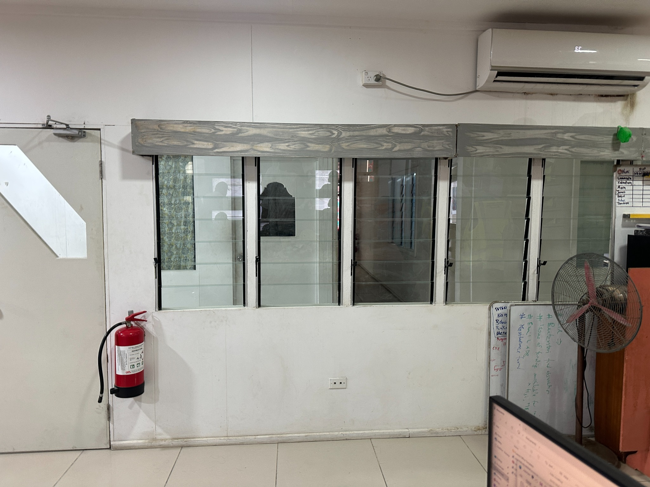
Figure 1. Indicative feature-wall arrangement supplied by the Client (design reference only)
.
Mandatory design intent: treated 90 x 45 mm timber-framed full-height wall; lined and painted solid portions above and below; aluminium-framed operable glass louvre modules; coordinated framing around the opening; safe, durable and freely operating installation; and finishes approved by the Client.

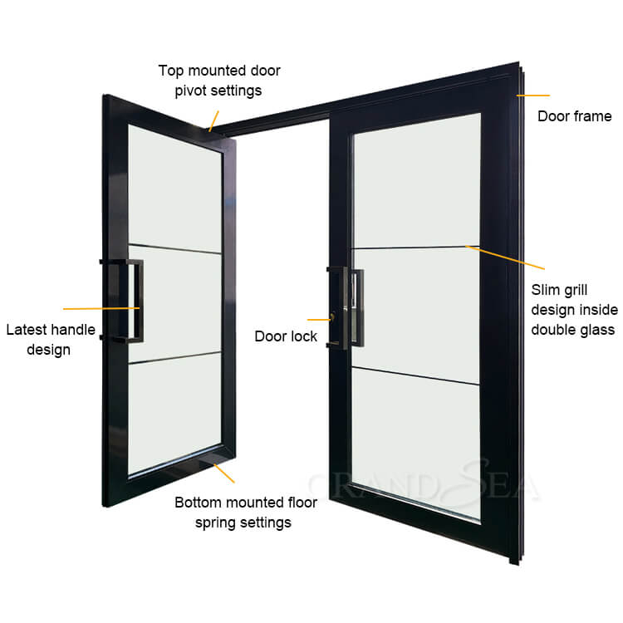
Figure 2. Indicative Aluminum swing double entrance door for second floor main entrance.

The image above is to be used as reference only. Contractor/supplier may supply equivalent commercial grade double entrance door that suits the profile and dimensions of the existing main curtain door in the second floor. Contractor/Supplier is required to seek confirmation by the Client before any imports or purchase.

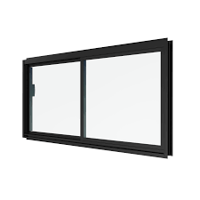
The image below is an indicative image of the Aluminum sliding window required for the kitchen in the ground floor. Contractor/supplier may supply equivalent commercial grade double entrance door that suits the profile and dimensions of the existing main curtain door in the second floor. Contractor/Supplier is require
Figure 3. Indicative Alumnium sliding window for ground floor kitchen

ANNEX 2A: BILL OF QUANTITIES

[To be completed, signed and submitted by the Bidder as an attachment to the signed Form of Quotation]

Project Title: Accelerating Trade Facilitation in the Pacific Project
Source of Funding (loan/credit/grant no.): P508537
Contract Name: PMU Office Renovation
Contract Ref: KI-MFED-540858-CW-RFQ

Refer to the attached file (Trade Summary)


AUTHORIZED SIGNATURE:
NAME AND TITLE OF SIGNATORY:
NAME OF BIDDER:

ANNEX 3: DRAWINGS

Project Title: Accelerating Trade Facilitation in the Pacific Project
Source of Funding (credit no.): P508537
Contract Name: PMU Office Renovation
Contract Ref: KI-MFED-540858-CW-RFQ

The drawing provides a conceptual visualisation of the scope of works to assist in the development of the detailed design. Final executable detailed design requires client approval



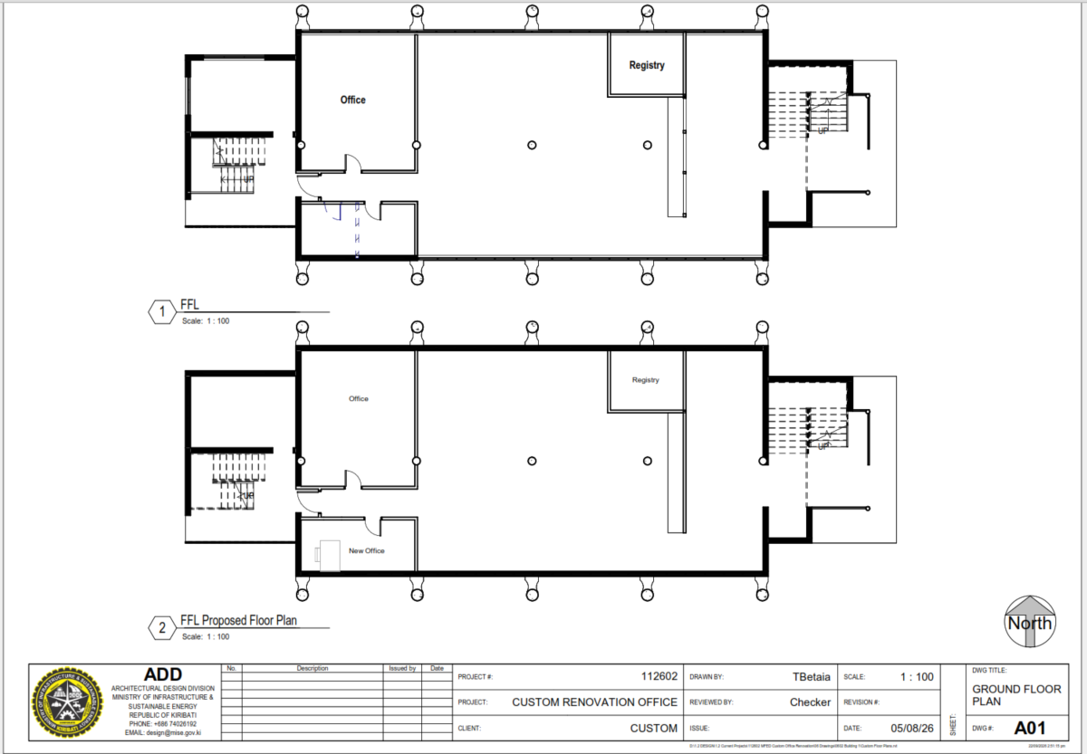
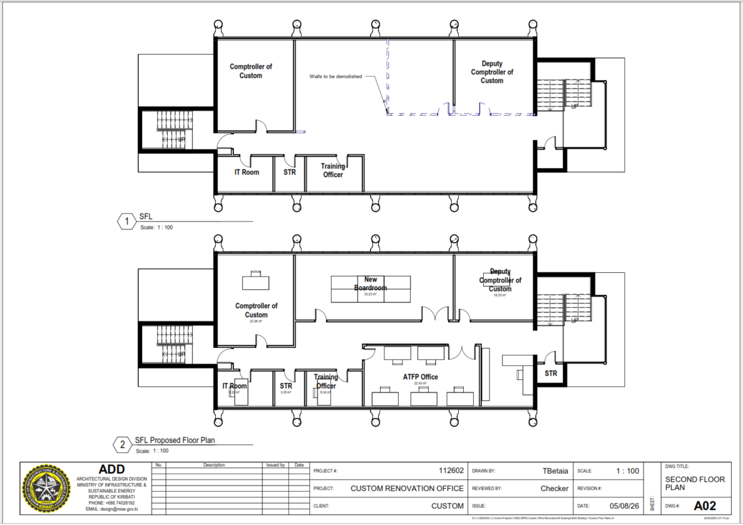
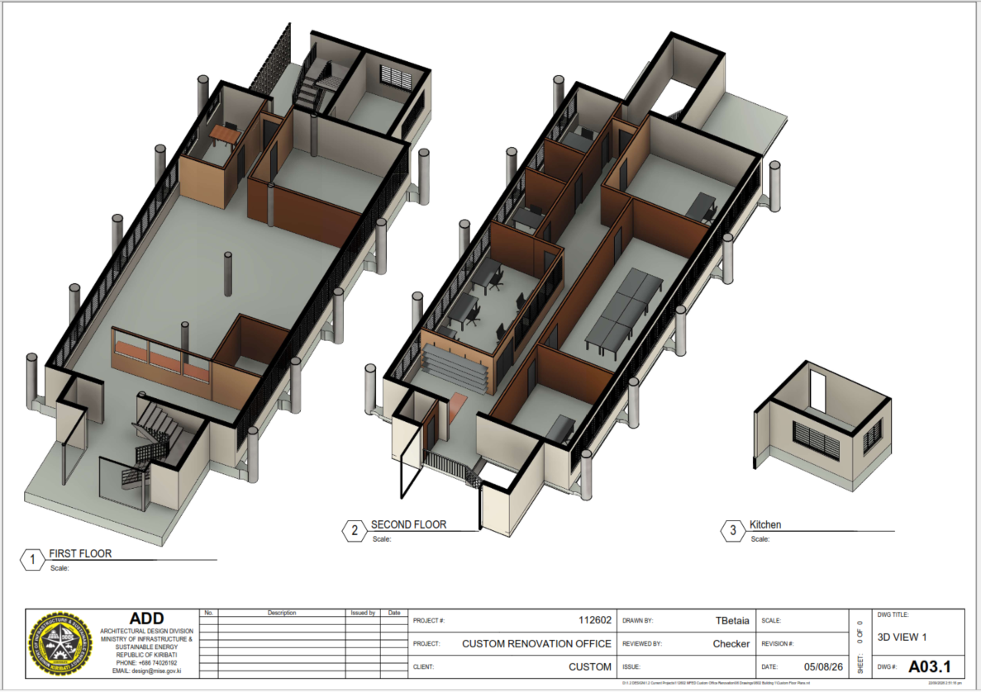
ANNEX 4: FORM OF QUOTATION (RFQ- WORKS)

[To be completed, signed and submitted on Letterhead of Bidder]

Project Title: Accelerating Trade Facilitation in the Pacific Project
Source of Funding (loan/credit/grant no.): P508537
Contract Name: PMU Office Renovation
Contract Ref: KI-MFED-540858-CW-RFQ

_________(Date)

To:_______________________________ (Employer’s Name)

_______________________________ (Employer’s Address)

We offer to execute the PMU Office Renovation - KI-MFED-540858-CW-RFQ in accordance with the Form of Contract and Specifications accompanying your Request for Quotation (RFQ) for the Contract Price of _________________________(amount in words and numbers) (______________ ) (AUD currency)_____________,including VAT. We propose to complete the Works described in the Contract within a period of [ninety(90)] calendar days from the Date of Signing of the Contract.

This Quotation and your written acceptance will constitute a binding Contract between us. We understand that you are not bound to accept the lowest or any Quotation you receive.

We hereby confirm that this Quotation complies with the Validity of the Quotation required by the RFQ.

Authorized Signature:
Name and Title of Signatory:
Name of Bidder:
Address:
Phone Number:
Email address:

Annex 5: Statement of Technical Compliance

Project Title: Accelerating Trade Facilitation in the Pacific Project
Source of Funding (loan/credit/grant no.): P508537
Contract Name: PMU Office Renovation
Contract Ref: KI-MFED-540858-CW-RFQ

Confirm compliance with each principal requirement. Where the response is ‘No’ or ‘Alternative’, provide full details and cross-reference supporting information. A blank response may be treated as non-compliance.
Ref. | Requirement | Yes | No | Departure / Alternative / Reference
C01 | Site inspected and dimensions/site conditions verified
C02 | All-inclusive design-and-build pricing basis accepted
C03 | Measured survey, preliminary design, detailed design, coordination, revisions and as-built documentation included
C04 | Full-height treated 90 x 45 mm timber partitions with studs at maximum 600 mm centres, noggings, linings and finishes included
C05 | Feature wall: full-height treated timber-framed and lined partition with inset aluminium-framed operable glass louvre-window bank approximately 8.80 m x 1.10 m, solid wall approximately 1.00 m below and 0.60 m above, generally similar to Appendix E
C06 | Operable glass louvre blades, aluminium frames/mullions, corrosion-resistant fixings, timber trimming, handles, seals, trims and coordinated installation included
C07 | Complete door sets, frames, glazing, hardware, finishes and making good included
C08 | Qualified electrical alterations, testing and certification included
C09 | Preliminary design submitted with quotation and coordinated detailed design submitted after award before construction
C10 | No design-dependent fabrication, procurement or construction before written approval of relevant design submission
C11 | Contractor accepts responsibility for design adequacy, coordination, constructability, compliance and correction of design deficiencies
C12 | Defects and non-conforming work rectified at no additional cost
C13 | Bidder confirms all waste disposal, landfill and tipping charges are included in the quoted price
C14 | Bidder accepts responsibility for repair of damage caused to existing facilities during construction.
C15 | Bidder agrees to immediately cease work and notify the Client if suspected asbestos or hazardous materials are encountered.
C16 | Bidder acknowledges the requirement for Client approval prior to demolition works
C17 | Bidder accepts the ECD inspection, suspected-asbestos stop work and written authorization requirements.
C18 | Bidder confirms that ordinary waste collection, transport and disposal charges are included in the quotation.
C19 | Bidder accepts the life and fire safety design requirements.

ATTACHMENT TO FORM OF QUOTATION
DETAILS OF BIDDER’S QUALIFICATIONS TO PERFORM THE CONTRACT
(refer paragraph 4 of the RFQ)
[To be completed, signed and submitted by the Bidder as an attachment to the signed Form of Quotation]

1. Experience as a works contractor (at least 1 over the last three years):
Contract No. 1
Contract title:
Description of the Works (include the description, nature and complexity similar to the works of this RFQ):
Contract period:
Final Contract Value:
Any other details:

2. Availability of Financial Resources:
The winning bidder should have adequate sources of finance to meet the cash flow requirements for at least 30% of the value of the works, in addition to requirements for works currently in progress.
Source of financing | Currency and Amount
1.

2.

3.

4.

Authorized Signature:
Name and Title of Signatory:
Name of Bidder:

