Building Appraisal Report for
TAK Office Building

Quality Control & Inspection Division

10th October 2026

Prepared for
Ministry of Tourism, Commerce, Industry and Cooperatives

Tourism Authority Kiribati
Betio, Tarawa



Document history and status
Revision | Date | Description | By | Review | Signature
0 | 08/10/26 | Draft report | MBE | RCI
1 |  | Revised Final Report | TCA | PQCE
2 |  | Final Report | ET | DABED

SCOPE & PURPOSE
The content of this report will evaluate based on the major and minor defects and what they could mean, appropriate recommendations on maintenance and remedial measures, technical information on the construction/topography of the property/land, building materials integrity, and requirements for any further specialist investigation.

This report should not be considered as a full detailed structural analysis report, but as a reasonable attempt based on observations and determinations of defects focused on the structural elements of the building and gave opinions as to whether the components are performing intentionally or in need of immediate repair. Other necessary recommendations incorporated are for the structure to be adequate, cost effective and safe.

CONVENTIONS USED IN THIS REPORT
Convention | Codes | Description
SATISFACTORY | S | Indicates the component is functionally consistent with its original purpose but  may show signs of normal wear and tear and deterioration.
MARGINAL | M | Indicates the component will probably require repair or replacement anytime within five  years.
POOR | P | Indicates the component will need repair or replacement now or in the very near future.
MAJOR CONCERNS | MC | A system or component that is considered significantly deficient or is unsafe.
SAFETY HAZARD | SH | Denotes a condition that is unsafe and in need of prompt attention.
NOT APPLICABLE | NA | This Component is not considered to be part of the building or within the scope of survey.

AERIAL SITE MAP
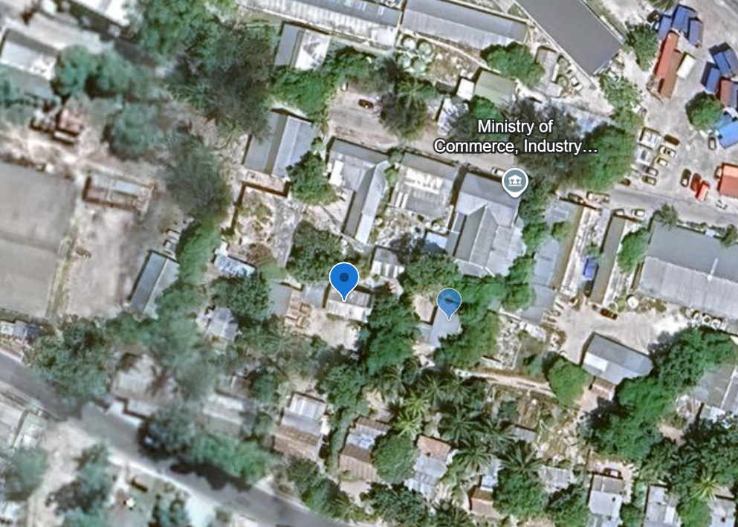
Figure 1. Tourism Office Site Location.

SITE SURVEY DATA CHECKLIST.
A | SURVEY DESCRIPTION
TYPE OF SURVEY |  | Structural Appraisal
REPORT NO. |  | 001 | DATE | 07/10/26
ADDRESS |  | Betio, Tarawa | WEATHER | Sunny
PREPARED BY |  | Maria Betaia, Tekaewaka Mwaio
PREPARED FOR |  | MTCIC
COORDINATES |  | 1°21'32.06"N 172°56'01.83"E
ATTENDEES |  | MTCIC OM, Maria, Tekaewaka
OWNERSHIP |  | ☒ Government owned ☐ NGO-owned ☐ Private-owned
A1 | STRUCTURAL APPRAISAL
Descriptions |  | Checked (x) |  | convention | Comments
 |  | Yes | No | convention | Comments

BUILDING DETAILS

As-built Details
- Building Classification |  | ☐ Class 1 ☐ Class 2 ☒ Class 3 ☐ Others
- Building Type |  | ☒ Office ☐ Classroom ☐ Warehouse ☐ Mwaneaba/Hall  ☐ Ablution Block ☐ Residential  ☐ Others _______________________________
- Occupancy |  | Not Occupied
- Usage |  | Office
- Building/Room Name |  | Kiribati Visitors Information Center
- Approx Age of building |  | n/a
- Main entrance face |  | South
- No. of Buildings |  | 1
- No. of Floor Levels |  | 2

Survey Scope
- Ground level |  | x |  | 3 office rooms and 1 washroom.
- 1st floor level |  | x |  | 3 office rooms
- Roofing level |  | x

MAIN BUILDING ELEMENTS CHECKED
  - Walls
- External walls |  | x |  | P | ☒Concrete/brick ☒Timber ☐others  1st floor concrete wall showing hairline cracks on the North and east side of the building. Under the windowsills, bond beam and corner end of the building. To be repaired 1st floor level external lining to be repaired and matched with existing material.
- Internal Walls |  | x |  | P | ☒Concrete/brick ☒Timber ☐others  Timber partition wall required repair for the common office room at the ground floor. Toilet concrete wall shows hairline cracks to be repaired.
- Door(s) |  | x |  | P | Shared office door to be repaired at the ground floor.
- Window(s) |  | x |  | P | All broken louvers are to be replaced with the building’s window.
- Opening frames |  | x |  | P | Door framing for the common office at ground floor to be fixed with the partition timber wall.
  - Roof
- Type |  |  |  |  | ☒Pitch roof ☐Half truss ☐Flattop ☐others
- Ceiling |  | x |  | MC | Ground floor ceiling requires repair, change ceiling nails to screws.
- Gable end(s) |  | x |  | P | Require replacement for lining for cable ends on the west end of the roof.
  - Electrical installation
- Wiring |  | x |  | MC | Needs re-wiring arrangement for power ports that have detached from ceilings.
    - Main switch board
- Power ports |  | x |  | MC | To be checked for rack re-attachment.
- Lights |  | x |  | MC | Light bulbs to be changed and light units to be re-fixed to ceiling for ground level and 1st level lightings.
- Air conditioning |  | x |  | MC | All indoor AC unit racks need to be checked and re-installed.
- OTHER BUILDING COMPONENTS
  - Walkway/Ramp/Stairs
- Accessibility |  | x |  | P | The stairways require replacement for wall lining.
  - Balcony/Terrance
- Floor type |  | x |  | P | Timber framing, West end of the balcony requires repair for floor beam replacement and landing.

B | INSPECTION PHOTOS
Images |  | Comments
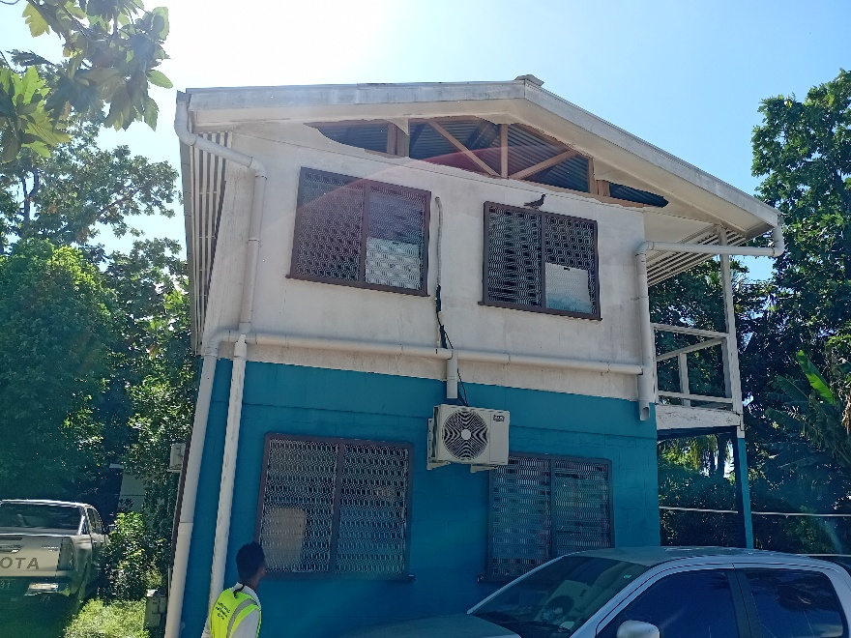 |  | West side of the building with broken window louvers, and gable end lining.  To be removed and replaced.  Materials  Window – clear glass louvers  Gable end lining – fiber cement sheet
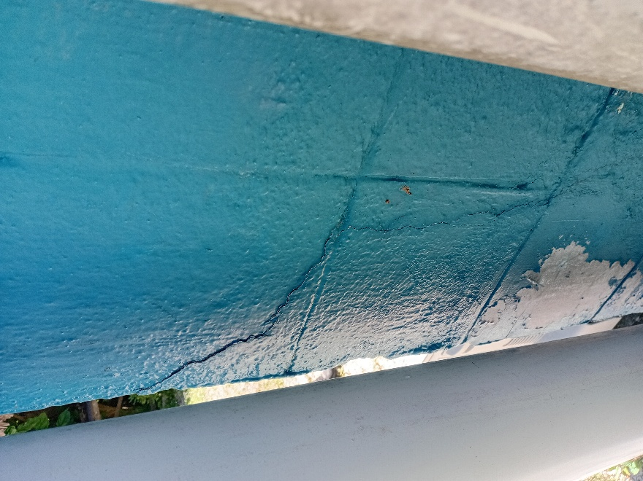 |  | Corner of the east to north wall behind the gutter down pipe. Crack repairing is required.  Material – cement mortar mix.  Repair method is up to the contractor’s recommendation in relation to the material provided.
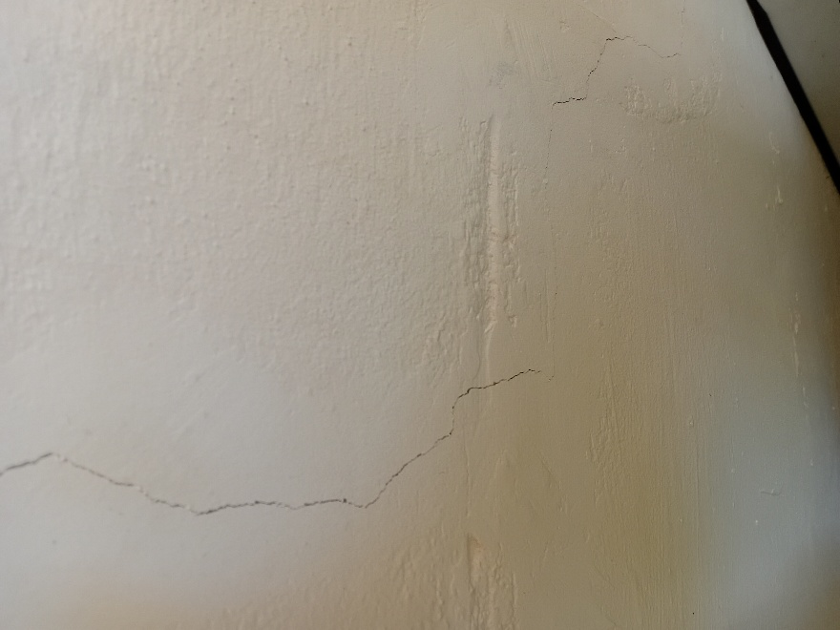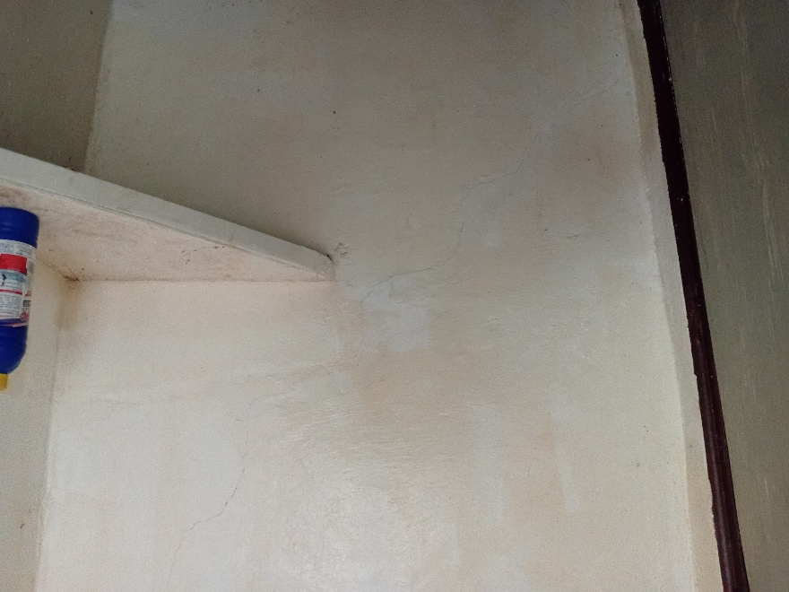 |  | Hairline crack on the internal wall for office corridor and toilet. Requires repair.  Material – cement mortar  Repair methods are up to the contractor’s recommendation in relation to the material provided.
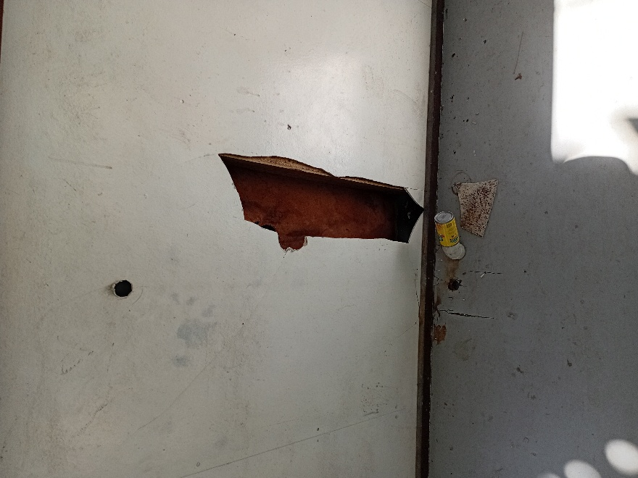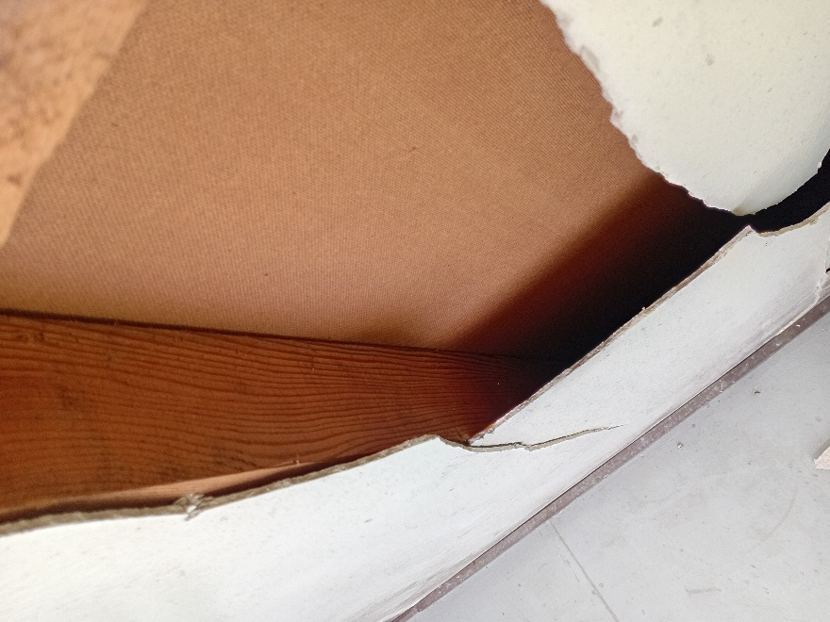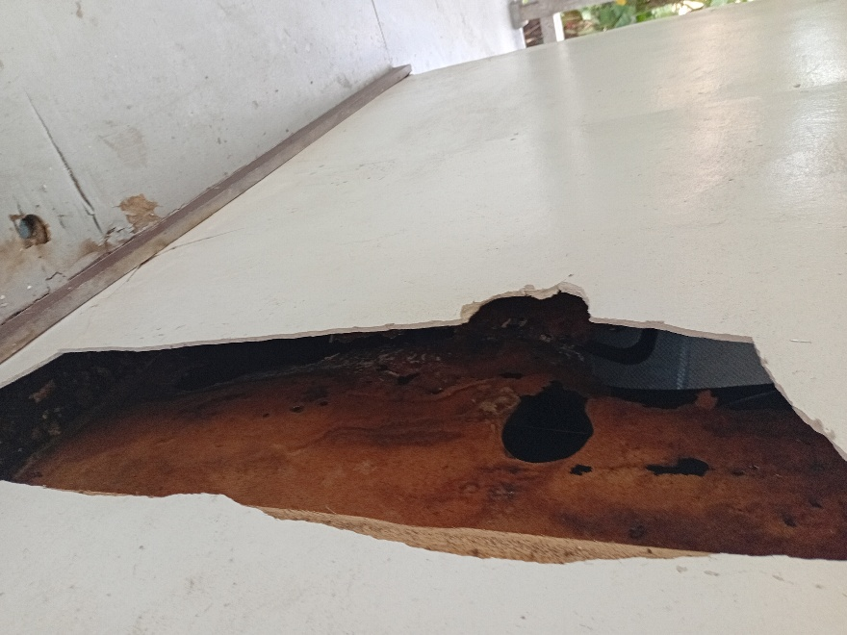 |  | The 1st floor external linings require replacement of broken cement fiber sheets around the 1st floor. The figure provided of the wall needs changing for the external and internal wall lining.  External wall – fiber cement sheet  Internal wall – Masonite sheet
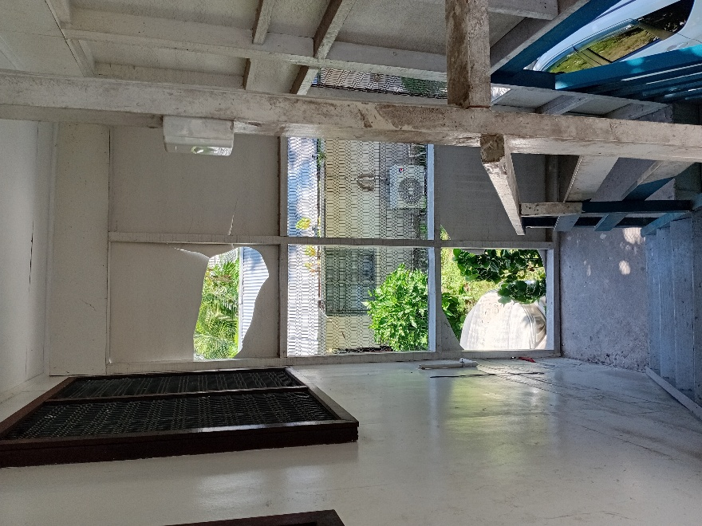 |  | Stairways wall lining to remove damaged walls and replace.  Material – fiber cement sheet.
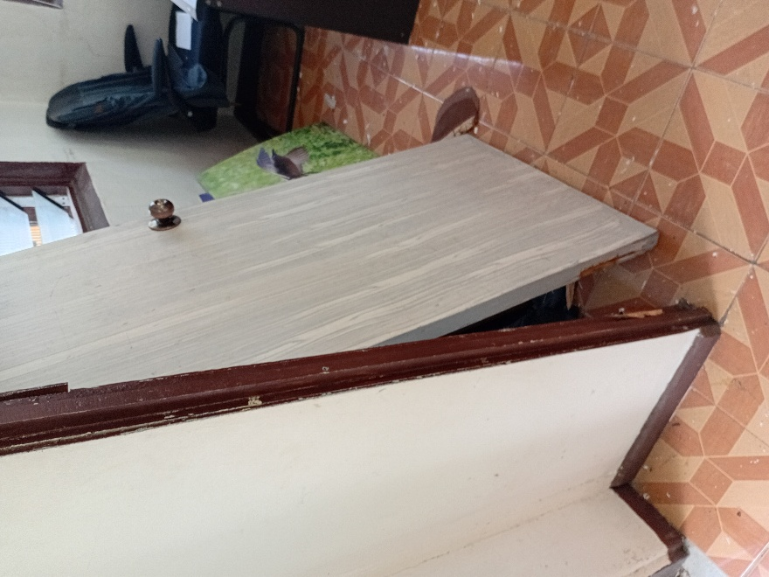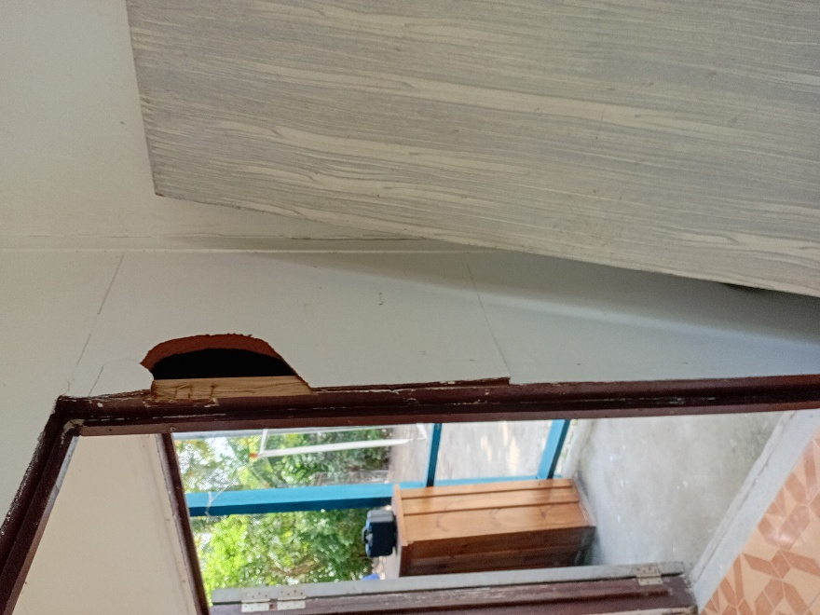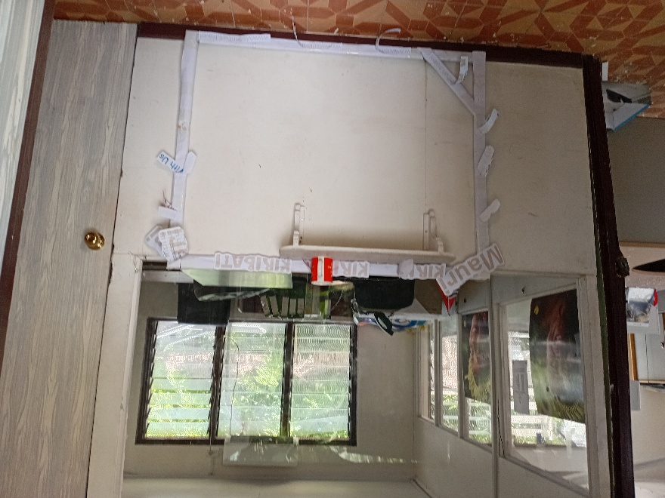 |  | Common office door, to be repaired with the wall partition and door framing.  Registry counter to be repaired for the corner towards the common rooms door.
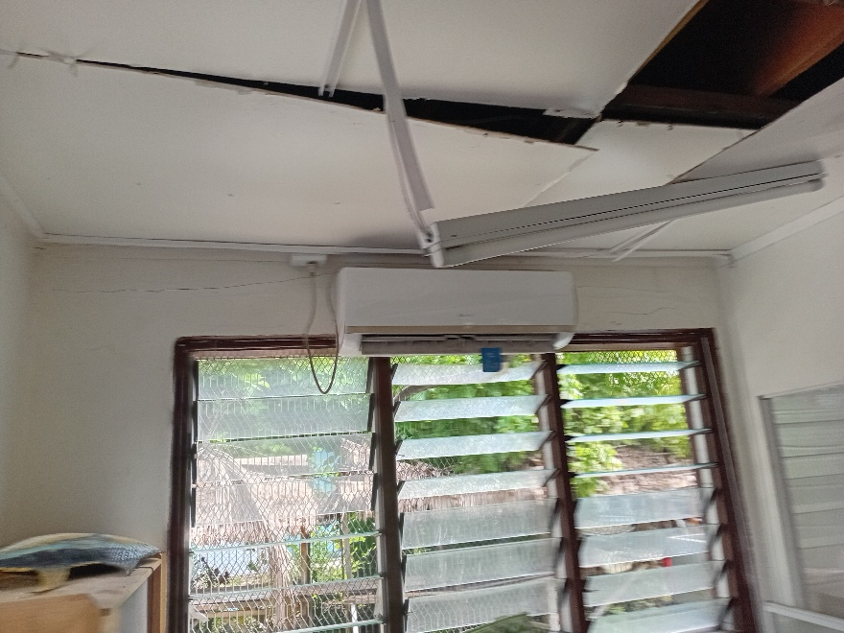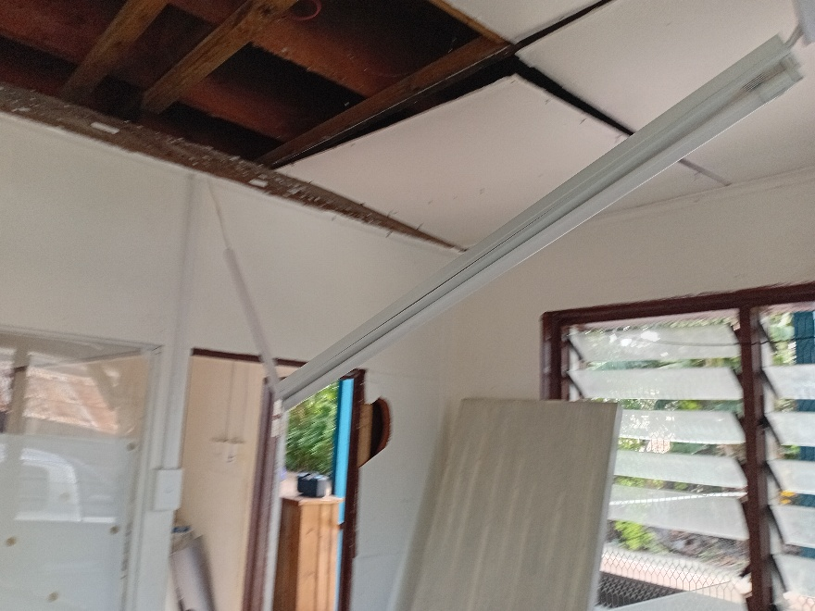 |  | Ceiling to be repaired and lighting units to be fixed to the ceiling. Bulbs for all lights are to be checked for replacement.  AC units and power points to be re-racked onto wall.
 |  | The bond beams behind the AC unit to be repaired as recommended for the repair method of the concrete cracks.

ENGINEERING REPORT & RECOMMENDATIONS
All recommendations are to be applied which are mentioned beside the attached figures.

CONCLUSION REMARKS
The survey data concludes that the overall condition of the building is structurally safe but with an overall Poor convention, which requires all recommendations to be repaired for the building to be useable and to be occupied.

Therefore, MISE -QCID strongly recommended that the repairs be undertaken immediately to stabiles the building condition. However, the above recommendations need to be completed as to expand its structural elements performance and lifetime of the building.

Building class 1 refers to a residential building
Building class 2 refers to a residential building occupied by a number of unrelated persons, e.g. boarding-house, dormitory, accommodation for aged, disabled or children, etc
Building class 3 refers to all other buildings including office buildings, shops, warehouse, assembly house, etc 4 Other building works indicated under Schedule 1 of the Building Act 2006

